Danish Monarchs
Author Name(s): Alexander Hilmer
Github URL for your rmarkdown/html files: html files: https://github.com/Digital-Methods-HASS/au802259_Hilmer_Alexander/blob/main/Week%2011/DanishMonarchs.html and rmd: https://github.com/Digital-Methods-HASS/au802259_Hilmer_Alexander/blob/main/Week%2011/DanishMonarchs.rmd
…………………………………………………………………………………………………………………….
Answer these questions by listing both the chunk of code you used and then the response
- What function did you use to load your dataset in R as a tibble? What do you see when you run head() on your ‘kings’ digital object?
I used the read_csv() to load in the dataset in R as a tibble.
How do you confirm your kings’ object in R is a tibble?
I used the class() function which tells me its a tbl aka tibble
Paste here a screenshot of the Console after running head(kings) or glimpse(kings):
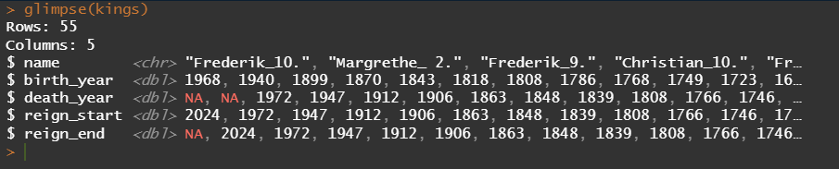
- What is the average age of reign among your monarchs and how many rulers have exceeded it?
Code
For calculation the average age of reign: 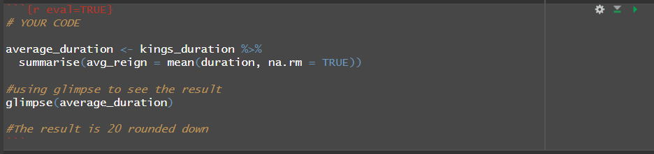
Result
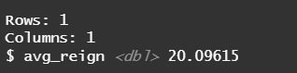
So the average age of reign is 20 rounded down.

For calculating how many rulers exceeded it
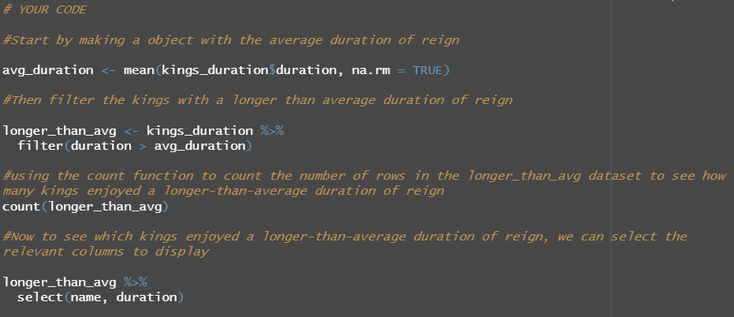
Result
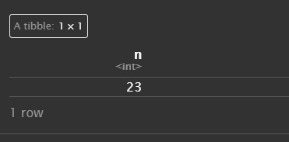
So there was 23 rulers that exceeded the average duration of reign.

- How many days did the three longest-ruling monarchs rule?
Code
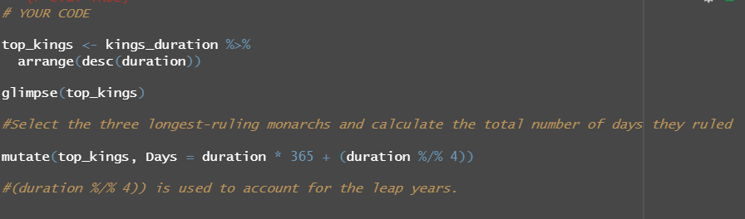
Result
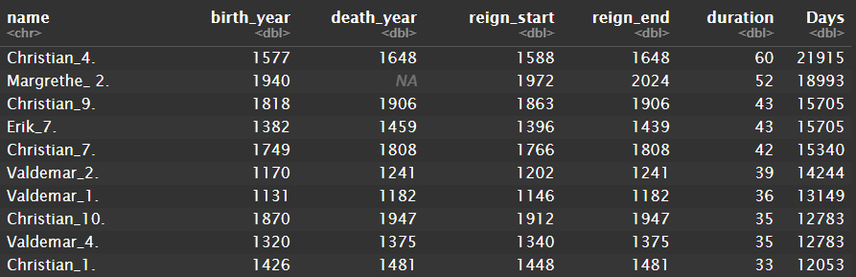
So the three longest-ruling monarchs ruled for respectively 21915, 18993 and 15705 days
- Challenge: Plot the duration of reign in time and briefly answer “What is the long-term trend in the duration of reign among monarchs?”
Author: Manuel Mørch
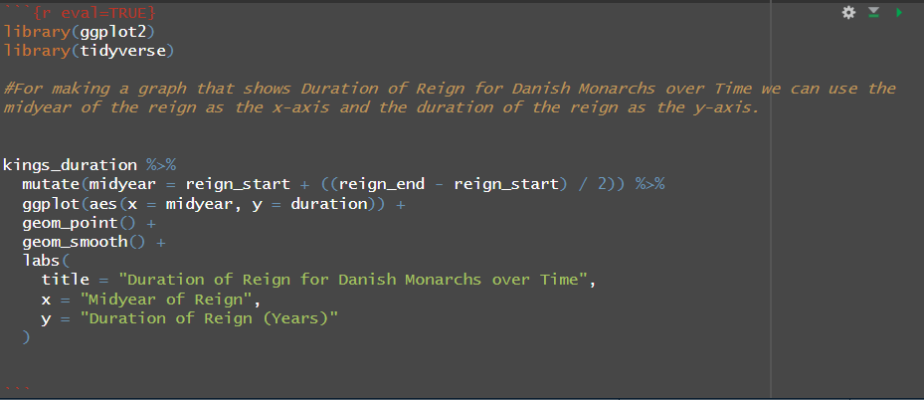
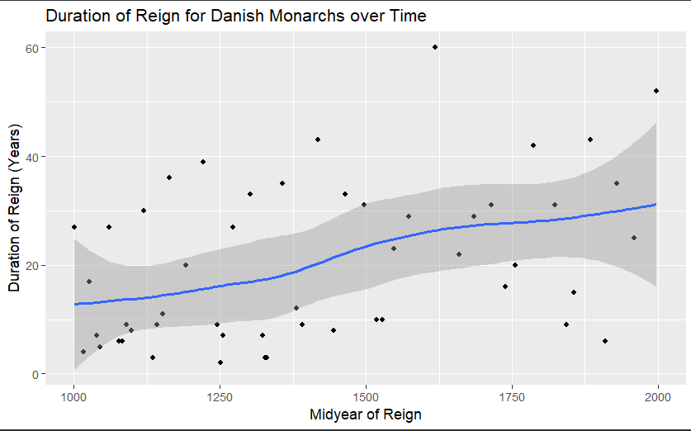
The long-term trend is that the duration of reign among monarchs rises as time goes by. This result might be influenced by the fact that humans in general live longer than they used to. So although we do see a rise in the time that monarchs reign it might be hard to determine anything useful from it.

